Scope Description
and Questionnaire

SAP Fieldglass Integration Add-on FP01
Document Version 9.32010-rev1
October 23, 2020

Table of Content
1 Introduction 3
2 General questions 4
2.1 SAP Fieldglass solution modules in scope of integration 4
2.2 Available integration scenarios 4
2.2.1 Invoice integration scenario 4
2.2.2 Procurement integration scenario 5
2.2.3 Plant Maintenance integration scenario 6
2.3 Integration scenario 7
2.4 Pre-requisites and system landscape 7
3 Master data integration 8
3.1 Organizational data 9
3.2 Cost objects 10
3.3 Vendor master 10
3.4 Users and roles 11
4 Transactional integration 12
4.1 Specific configuration for procurement and plant maintenance integration scenarios 12
4.1.1 Document Types 12
4.1.2 Account Assignment Categories (AAC) 12
4.1.3 Approval workflows 12
4.1.4 PR/PO creation and revision process 13
4.1.5 PO Attachment transfer 13
4.2 Specific configuration for ‘Contingent Workforce Management’ integration 13
4.2.1 Worker / HCM integration 13
4.2.2 Service Entry Sheets 14
4.3 Specific configuration for ‘Services Procurement’ integration 14
4.3.1 SOW SES Integration 14
4.3.2 Plant Maintenance Integration (PM) 14
4.3.3 Project System Integration (PS) 14
5 Miscellaneous 15

Introduction
SAP Fieldglass Integration Add-on is the integration solution for SAP Fieldglass with SAP NetWeaver systems, available with a subscription license of SAP products
- SAP Fieldglass Contingent Workforce Management, ERP edition
- SAP Fieldglass Services Procurement, ERP edition
The purpose of this document is to present the configuration capabilities and to query Customer choice on the different options available.
The Integration approach leverages an Add-on, installed to supported* SAP ERP® or SAP S/4HANA® systems, and SAP Cloud Platform® to communicate with SAP Fieldglass® solutions.
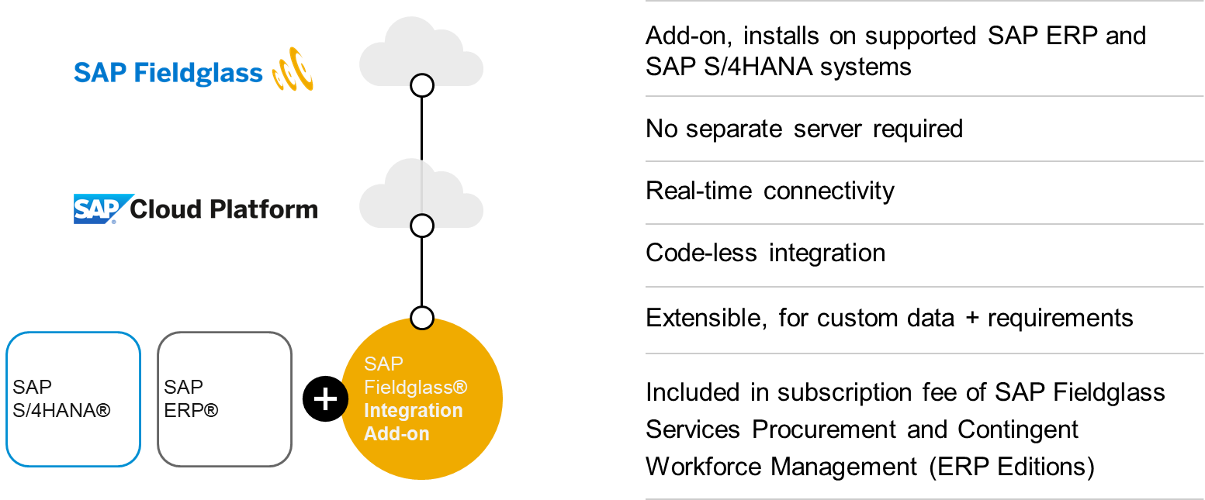

* please see ‘Technical Requirements’ document for info about supported SAP NetWeaver® systems. Integration with SAP S/4HANA is e.g. not supported for SAP S/4HANA Cloud editions and ‘Lean Services’ scenario.

General questions

SAP Fieldglass solution modules in scope of integration
Please choose your Fieldglass Module(s), that should be in scope of integration
☐ SAP Fieldglass® Contingent Workforce Management
☐ SAP Fieldglass® Services Procurement (Statement of Work)
Note: please choose at least 1 option

Available integration scenarios

Invoice integration scenario
Integration points marked as ‘X’ are available, depending on the SAP Fieldglass® solutions:
Integration | Contingent Workforce Management | Services Procurement
Master data | X | X
Invoice | X | X
Optional: Worker/HCM integration | X | -

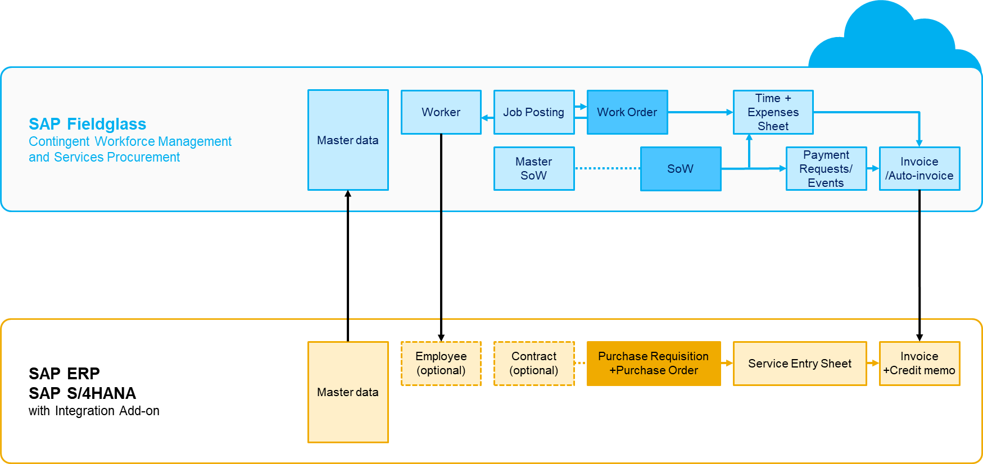

Procurement integration scenario
Integration points marked as ‘X’ are available, depending on the SAP Fieldglass® solutions:
Integration | Contingent Workforce Management | Services Procurement
Master data | X | X
Work Order | X | -
SoW | - | X
Time Sheet | X | X
Expense Sheet | X | X
Payment Requests | - | X
Invoice | X | X
Optional: Worker/HCM integration | X | -
Optional: Contract/MSoW integration | - | X

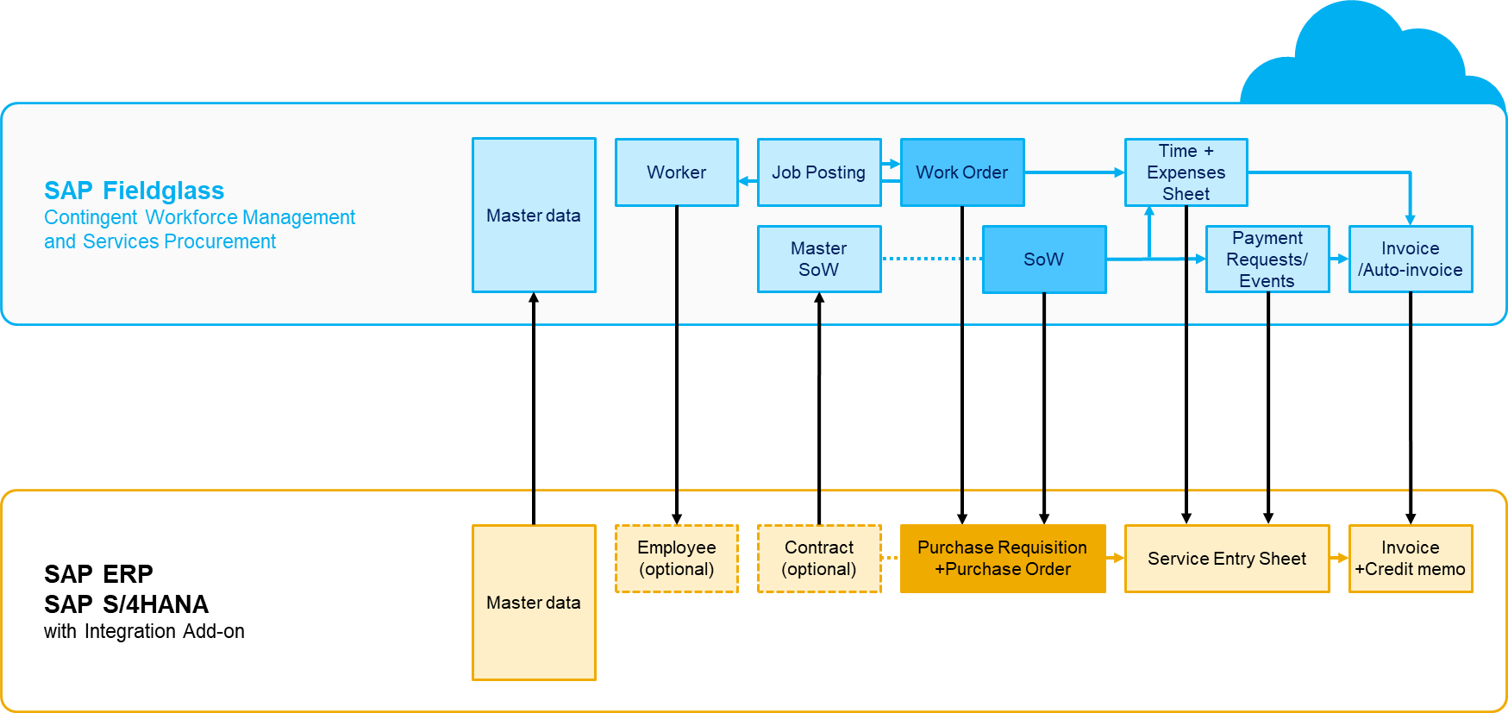

Plant Maintenance integration scenario
Integration points marked as ‘X’ are available, depending on the SAP Fieldglass® solutions:
Integration | Contingent Workforce Management | Services Procurement
Master data | X | X
Work Order | X | -
SoW | - | X
SoW from PS Network Activity | - | X
SoW from PM Order Operation | - | X
Time Sheet | X | X
Expense Sheet | X | X
Payment Requests | - | X
Invoice | X | X
Optional: Worker/HCM integration | X | -
Optional: Contract/MSoW integration | - | X
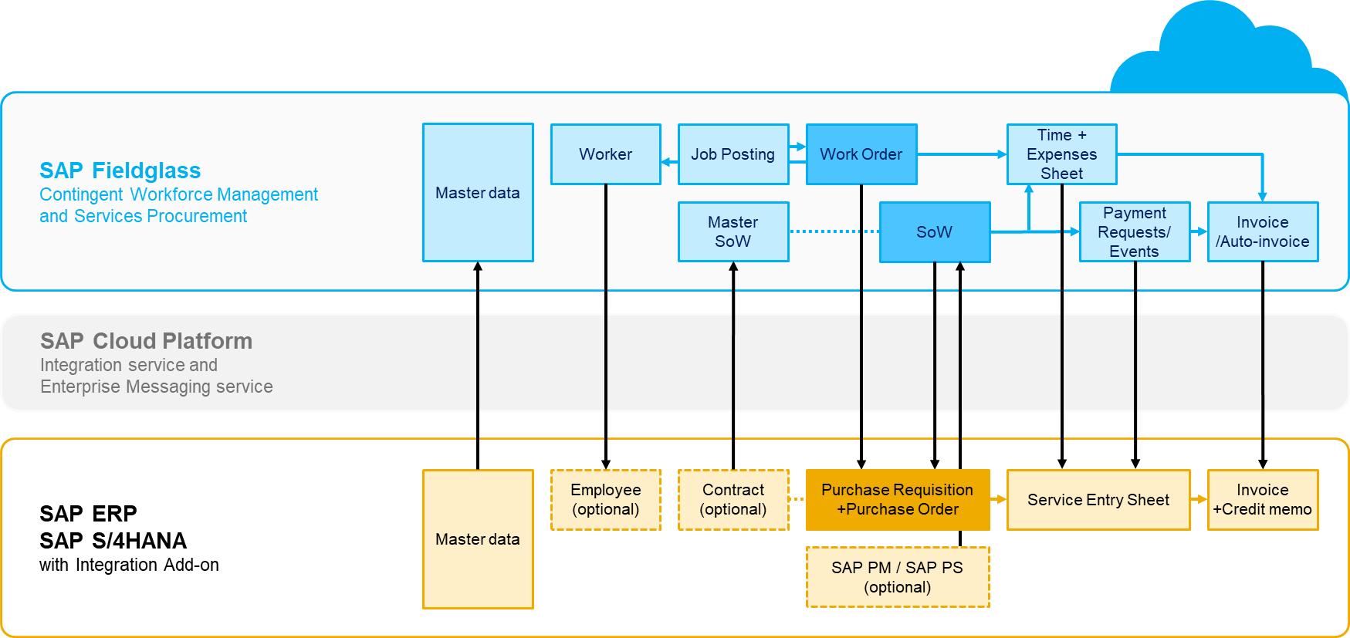

Integration scenario
Please choose the required integration scenario
☐ Invoice Integration
☐ Procurement Integration (Recommended Solution, Default Setting)
☐ Plant Maintenance Integration
Note: please choose 1 option

Pre-requisites and system landscape
Do you use separate clients in your development system for customizing, workbench and unit testing?
☐ No, single SAP client setup. Client ID: Klicken oder tippen Sie hier, um Text einzugeben.
☐ Yes, multi-client setup. In case of multi-client setup, please specify the client IDs and their purpose:
Klicken oder tippen Sie hier, um Text einzugeben.
Note: please choose only 1 option

Are the technical pre-requisites fulfilled, according to the applicable ‘Technical Pre-requisites’ and ‘Deployment Description’ documentation ?
- Minimum system requirements are met for installation of the Add-on onto an SAP ERP or SAP S/4HANA systems*
- Add-on installed on development landscape at project start
- Connection set-up between backend system and SAP Cloud Platform, using SAP Cloud Connector
- Required SAP Cloud Platform Services activated
☐ Yes
☐ No, but will be completed during ‘Discover’/’Prepare’ phase
* please see ‘Technical Requirements’ document for info about supported SAP NetWeaver® systems. Integration with SAP S/4HANA is e.g. not supported for SAP S/4HANA Cloud editions and ‘Lean Services’ scenario.

Master data integration
Master data integration is required for all transactional integrations. Overview of Master data integration points:
SAP Fieldglass object | Configuration options | Special features
Legal Entities | Company codes (code and description) | Filter function available, to restrict list of company codes
Business Units | - Purchasing organisations from SAP system  - Organizational units from SAP system  - Company codes from SAP system | Only purchasing organisations assigned to the selected company codes (‘Legal Entities’) will be uploaded
Sites | Plants (code and description) | Filter function available, to restrict list of plants
Locations | - Storage locations  - EHS work areas | Work areas from SAP EHS are supported
Users and roles | - Users  - Roles, mapped to SAP Fieldglass roles | Fully manage your SAP Fieldglass users with established SAP user management processes
Suppliers (real-time capable) | - Upload existing suppliers  - Auto-invite existing suppliers | Mark vendors for upload, using vendor classification: ‘Temp. Labor” for Contingent Workforce, ‘SoW Worker’ for Services Procurement, or both.
Cost objects (real-time capable) | - Cost centers  - WBS elements  - Internal orders  - Network activities  - PM orders | Considers relation of accounting objects to  company code
G/L accounts (real-time capable) | G/L accounts | Considers relation of G/L accounts to company codes
Task codes | Company codes + Task codes | Creates task codes from company codes and G/L accounts

Organizational data
Please choose which master data you want to integrate. If there are different variants for an integration, please also choose one of the listed options.
☐ Create ‘Legal Entities’ in SAP Fieldglass from SAP Company Code (Recommended Solution, Default Setting)
A filter function is available in the Add-on configuration, to restrict data to relevant SAP Company Codes
Filter settings: Please specify which company codes shall be integrated (e.g. 1000, 2000, …):
Klicken oder tippen Sie hier, um Text einzugeben.
If no filter is defined, all company codes will be uploaded.
Recommended Solution: specify only SAP Company Codes that should be enabled for SAP Fieldglass processes.

Business Units
☐ Purchasing organizations from SAP system (Recommended Solution, Default Setting)
Only purchasing organizations assigned to the selected SAP company codes (see ‘Legal Entities’) will be uploaded.
☐ Organizational Units from SAP system
☐ Company Codes from SAP system
Note: please choose 1 option

☐ Create ‘Sites’ in SAP Fieldglass from SAP Plants (Recommended Solution, Default Setting)
A filter function is available in the Add-on configuration, to restrict data to relevant SAP Plants
Filter settings: Please specify which plant codes shall be integrated (e.g. 1001, 1001, …):
Klicken oder tippen Sie hier, um Text einzugeben.
If no filter is defined, all SAP plant codes will be uploaded.
Recommended Solution: specify only SAP Plants that should be enabled for SAP Fieldglass processes.

Locations:
☐ Storage Location (Recommended Solution, Default Setting)
☐ HSE Work Area
Note: Please choose 1 option

Cost objects
Upload SAP accounting objects as SAP Fieldglass Cost Collectors:
☐ Cost Center (Recommended Solution, Default Setting)
☐ WBS Element (Recommended Solution, Default Setting)
☒ Internal Order (Recommended Solution, Default Setting)
☐ Network Activity
☐ PM Order
Note: Please choose at least 1 option

☐ G/L accounts (Recommended Solution, Default Setting)
☐ Create ‘Task Codes' in SAP Fieldglass from SAP Company Codes and assign to G/L accounts. Please choose this option, if G/L accounts in SAP backend system do have a relation to SAP company codes.
☐ Additionally, create a reference from ‘Task Codes’ to ‘Cost Center’ objects. Please choose this option, if selection of cost center by the user should allow for filtering by ‘Task Codes’.
Note: Please choose at least 1 option

Vendor master
☐ Vendor Master (Recommended Solution, Default Setting)
Vendors relevant for the upload can be marked through vendor classification feature in SAP.
The Add-on installs an additional classification value ‘Vendor Master Upload Info’, with 3 available characteristics: ‘Temp. Labor” for Contingent Workforce Management, ‘SoW Worker’ for Services Procurement and both.
You can assign this classification to the relevant vendors.
Please note: If you do not choose this option, correct and matching vendor data in SAP Fieldglass needs to be created manually, including the SAP vendor id mapping.

Auto-invite feature: (Recommended Solution, Default Setting)
☐ Send invitation to vendor from the VMS directly. If you do not choose this functionality, the invitation must be sent manually from SAP Fieldglass to the vendor.

Users and roles
☐ Create SAP Fieldglass ‘Users’ from SAP User ids (SU01) and assign SAP Fieldglass ‘Role’ from SU01 role assignment
Please note: If you want to integrate SAP users to SAP Fieldglass, it is required to also integrate business units. Furthermore, a role mapping is required.
Recommended solution: create SAP shell roles (PFCG roles, without authorization objects) in your SAP system, matching the SAP Fieldglass role names.
- These roles need to be mapped against the actual SAP Fieldglass role names in the Add-on configuration.
- Please provide the SAP Fieldglass role names you are planning to use and map the SAP role names accordingly in the table below.
- Since you can only assign one role in SAP Fieldglass to a user, you should only assign one SAP shell role as well. In case you require multiple roles assignments, please specify the priority by which roles should be selected (Priority 1 = being the highest)
SAP Fieldglass role name | SAP ERP role name | Priority
e.g. Manager | e.g. ZFG_MANAGER | 1
e.g. User | e.g. ZFG_USER | Klicken oder tippen Sie hier, um Text einzugeben.
e.g. custom-specific roles | Klicken oder tippen Sie hier, um Text einzugeben. | Klicken oder tippen Sie hier, um Text einzugeben.
Klicken oder tippen Sie hier, um Text einzugeben. | Klicken oder tippen Sie hier, um Text einzugeben. | Klicken oder tippen Sie hier, um Text einzugeben.
Klicken oder tippen Sie hier, um Text einzugeben. | Klicken oder tippen Sie hier, um Text einzugeben. | Klicken oder tippen Sie hier, um Text einzugeben.
Klicken oder tippen Sie hier, um Text einzugeben. | Klicken oder tippen Sie hier, um Text einzugeben. | Klicken oder tippen Sie hier, um Text einzugeben.
Klicken oder tippen Sie hier, um Text einzugeben. | Klicken oder tippen Sie hier, um Text einzugeben. | Klicken oder tippen Sie hier, um Text einzugeben.
Klicken oder tippen Sie hier, um Text einzugeben. | Klicken oder tippen Sie hier, um Text einzugeben. | Klicken oder tippen Sie hier, um Text einzugeben.
Klicken oder tippen Sie hier, um Text einzugeben. | Klicken oder tippen Sie hier, um Text einzugeben. | Klicken oder tippen Sie hier, um Text einzugeben.
Klicken oder tippen Sie hier, um Text einzugeben. | Klicken oder tippen Sie hier, um Text einzugeben. | Klicken oder tippen Sie hier, um Text einzugeben.
Klicken oder tippen Sie hier, um Text einzugeben. | Klicken oder tippen Sie hier, um Text einzugeben. | Klicken oder tippen Sie hier, um Text einzugeben.

Transactional integration

Specific configuration for procurement and plant maintenance integration scenarios

Document Types
Purchase Requisition document type: (Default Setting: NB)
Klicken oder tippen Sie hier, um Text einzugeben.
Purchase Order document type: (Default Setting: NB)
Klicken oder tippen Sie hier, um Text einzugeben.
Recommended solution: use dedicated document types for purchase requisitions and purchase orders originating from SAP Fieldglass, for example “ZFG”.
Note: Please provide the document types you want to use and make sure those exist in your system.

Account Assignment Categories (AAC)
You can decide to use either account assignment category “U – Unknown” for all of your PRs/POs in general which allows the integration to post the service entry sheet later in the process against whatever cost collector will be selected on the TS/ES/SOW Char. or the proper cost assignment category (K/F/P/N) of the selected cost collector in the Work Order / Statement of Work which will limit the cost allocation in the SES to only use the cost collectors available in the PO.
☐ Yes, only use account assignment category “U” for PR and PO (Recommended Solution, Default Setting)
☐ No
Note: please choose only 1 option

Approval workflows
It is recommended to use approval workflows in SAP Fieldglass on the Work Order / Statement of Work instead of having them sit in SAP. However, approvals on the PR are supported by the integration. This decision has impacts on the integration flow.
Use approval workflows on SAP purchase requisitions?
☐ Yes, approvals on PR level are required.
☐ No (Recommended Solution, Default Setting)
Note: please choose only 1 option

PR/PO creation and revision process
There are different integration scenarios for creating PR/PO as well as for the revision process:
Do you want to integrate the Work Order / Statement of Work through PR/PO or only PO?
☐ Integration through PR and PO (Recommended Solution, Default Setting)
☐ Integration without PR, only PO
Note: please choose only 1 option
Revision scenarios:
☐ Update and revise the original PR and PR item (Only available if revisions only pertain changes to budget and/or cost collectors of the same AAC as the original document. No changes of AAC). PO will be updated directly or after PR approvals if required. (Recommended Solution, Default Setting)
☐ Creation of delta PR. Original PR will not be updated in case of budget increase. In this case a new PR with the delta amount will be created. PO will be updated with another item. In case of budget decrease the existing PR will be updated.
☐ Update PO without PR update. All changes will be directly updated on the PO without changing the PR.
Note: please choose only 1 option

PO Attachment transfer
Do you want to upload the standard PO Preview Output PDF as an attachment to the WO/SOW?
☐ Yes
☐ No (Recommended Solution, Default Setting)
Note: please choose only 1 option

Specific configuration for ‘Contingent Workforce Management’ integration
You only need to choose from the following sub-chapters if you want to integrate the contingent work module

Worker / HCM integration
Do you want to integrate the worker data from SAP Fieldglass into SAP HCM employee master?
☐ Yes
☐ No (Recommended Solution, Default Setting)
Note: please choose only 1 option

Service Entry Sheets
Which kind of SES integration is required?
☐ SAP Fieldglass Timesheets to SAP SES integration (Recommended Solution, Default Setting)
☐ SAP Fieldglass Expense Sheets to SAP SES integration (Recommended Solution, Default Setting)

Specific configuration for ‘Services Procurement’ integration
Only applicable if ‘Services Procurement’ module of SAP Fieldglass shall be integrated.

SOW SES Integration
Which kind of SOW characteristics will be required to be integrated with service entry sheets?
☐ SOW Fees (Recommended Solution, Default Setting)
☐ SOW Events
Note: please choose at least 1 option

Plant Maintenance Integration (PM)
Do you want to integrate Plant Maintenance external operations to SAP Fieldglass?
☐ Yes, upload purchase requisitions from Plant Maintenance to SAP Fieldglass as a SOW
☐ No (Default Setting)
Note: please choose only 1 option

Project System Integration (PS)
Do you want to integrate Project System to SAP Fieldglass?
☐ Yes, upload purchase requisitions from Project System to SAP Fieldglass as a SOW
☐ No (Default Setting)
Note: please choose only 1 option

Miscellaneous
Any positive answer would cause additional implementation efforts on both SAP Fieldglass application side as well as on SAP backend integration side.
Do you want to integrate ‘Miscellaneous Invoices’ to SAP backend system?
☐ Yes, SAP Fieldglass Miscellaneous Invoice integration is required
☐ No (Default Setting)
Note: please choose only 1 option

Do you have mandatory custom fields on one of the following SAP documents, that would require an integration with SAP Fieldglass documents?
☐ SAP Purchase Requisition
☐ SAP Purchase Order
☐ SAP Service Entry Sheet
☐ SAP Invoice
Recommended solution: no mandatory custom fields

